Michael Weaver

CST – 235

Brandon Bass

11/12/2017

**Short Assignment 1B**

To complete this assignment I decided to build a FileReader class, an entityBean class, and a main class. The FileReader extracts all of the necessary info from the provided Reading text file. It then uses an EntityBean to count all of the words and characters in the file, as well as identifying if the current inputstream.next is an integer. The main class then prints this information out to the console as I have yet to hook up the webserver to the Elcipse IDE.

**List of Included Material**

Main Class

Main access method for program

FileReader class

Constructor which takes a filename string

Private EntityBean field with public get method

Private ReadFile method used to read all data in the provided file into the bean

Private isInteger method used to determine if a string is an integer

EntityBean class

Serial ID field

Public no argument constructor

Private number of characters field with public set, get, and increment methods

Private number of words field with public set, get, and increment methods

Private sum of numbers field with public set, get, and increment methods

**Entity / Session discussion**

For this project a session bean is adequate for completion. If the program required persistent data, then an entity bean would be required. Substituting for an entity bean would require the injection of a framework allowing persistent data management. This would require some form of database or read to file method. This can easily be accomplished by adding additional classes to the project and editing the main call method.

**Proof of completion**

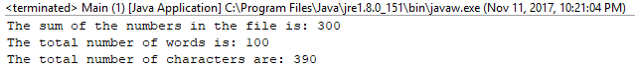

**GitHub Link**

https://github.com/battousairurik/CST-235